SIMPLE PERIOD TRACKER
The purpose of this project is to help women feel more comfortable; this project helps to identify when is the next period cycle and also gives tips to help reduce the period stress

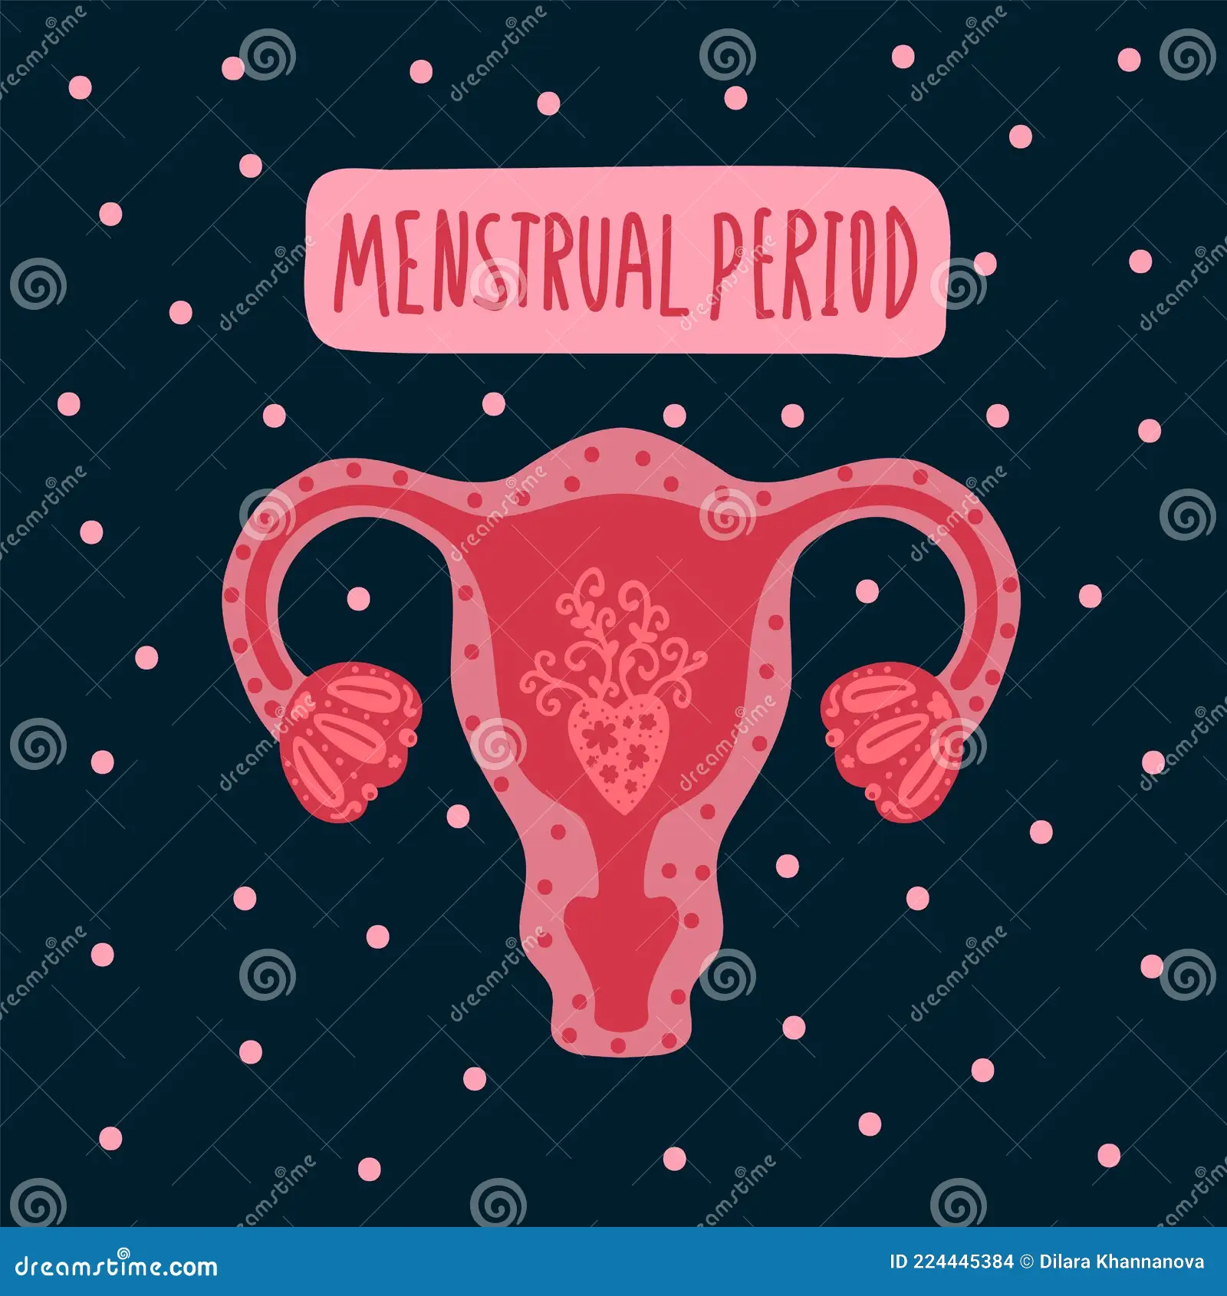

FEATURES:

- Simple and easy to use
- Prediction based on previous data
- Displays a random health tip
- Beginner-friendly

GitHub repository link:

The sample:

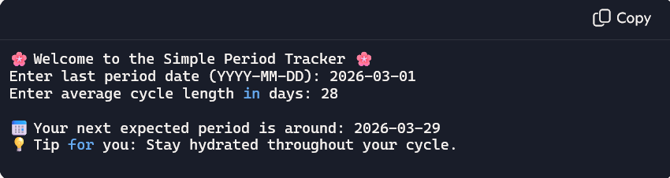

FUTURE IMPROVEMENT:

- Handle irregular cycles with simple ML models. Add a web interface using Flask/Streamlit.
- Store user history for better predictions.
- Notifications/reminders for upcoming cycles.
THIS PROJECT GIVE US
- Can help in tracking the length
- Ensures regular period
- Helps to track the cycle
- Cycle pattern observation
- Easy to use and accessible
- Simple design

